1.1 Introduction to computer graphics

The term ‘Computer Graphics’ was coined by Verne Hudson and William Fetter from Boeing who were pioneers in the field. Computer graphics is a dynamic and essential field within computing that involves the creation, manipulation, and rendering of visual content using computers.
In today’s digital era, computer graphics technologies have revolutionized how we perceive and interact with visual information, playing a pivotal role in video games, movies, architectural design, medical imaging, and more. There are several tools used for the implementation of Computer Graphics. The basic is the graphics.h header file in Turbo-C, Unity for advanced, and even OpenGL can be used for its Implementation.

What is Computer Graphics?
Computer Graphics including digital images, animations, and interactive graphics used in various sectors such as entertainment, education, scientific visualization, and virtual reality. Computer Graphics can be used in UI design, rendering, geometric objects, animation, and many more. In most areas, computer graphics is an abbreviation of CG.
Computer Graphics refers to several things
- The manipulation and the representation of the image or the data in a graphical manner.
- Various technology is required for the creation and manipulation.
- Digital synthesis and its manipulation.
Types of Computer Graphics
- Raster Graphics: In raster, graphics pixels are used for an image to be drawn. It is also known as a bitmap image in which a sequence of images is into smaller pixels. Basically, a bitmap indicates a large number of pixels together.
- Vector Graphics: In vector graphics , mathematical formulae are used to draw different types of shapes, lines, objects, and so on.
Applications of Computer Graphics
There are many applications of computer graphics discussed below-
- Computer Graphics are used for the aided design of systems engineering and architectural systems- These are used in electrical automobiles and electro-mechanical, and electronic devices. For example gears and bolts.
- Computer Art – MS Paint.
- Presentation Graphics – It is used to summarize financial statistical scientific or economic data. For example- Bar charts systems and line charts.
- Entertainment- It is used in motion pictures, music videos, and television gaming.
- Education and training- It is used to understand the operations of complex systems. It is also used for specialized systems such as framing for captains, pilots, and so on.
- Visualization- To study trends and patterns. For example- Analyzing satellite photos of earth.

Why are Computer Graphics used?
Imagine a car manufacturing company that wants to showcase its vehicle sales over the past decade. Storing and presenting this huge amount of data can be both time-consuming and memory-intensive. Furthermore, it can be difficult for the average person to understand. In such cases, by using graphics can be a more effective solution. By using charts and graphs to visually signify the data, it becomes much easier to understand and analyse the data.
Interactive computer graphics utilize a two-way communication concept between users and computers. The computer receives input signals from the user, and the picture is modified accordingly. When a command is applied, the picture updates promptly.

1.2 Display devices
Random scan display

In Random-Scan Display electron beam is directed only to the areas of screen where a picture has to be drawn. It is also called vector display, as it draws picture one line at time. It can draw and refresh component lines of a picture in any specified sequence. A Pen plotter is an example of random-scan device. The number of lines regulates refresh rate on random-scan displays. An area of memory called refresh display files stores picture definition as a set of line drawing commands. The system returns back to first-line command in the list, after all the drawing commands have been processed. High-quality vector systems can handle around 100, 00 short lines at this refresh rate. Faster refreshing can burn phosphor. To avoid this every refresh cycle is delayed to prevent refresh rate greater than 60 frames per second. Suppose we want to display a square ABCD on the screen. The commands will be:
- Draw a line from A to B
- Draw a line from B to C
- Draw a line from C to D
- Draw a line from D to A
Random-Scan Display Processors: Input in the form of an application program is stored in the system memory along with graphics package. Graphics package translates the graphic commands in application program into a display file stored in system memory. This display file is then accessed by the display processor to refresh the screen. The display processor cycles through each command in the display file program. Sometimes the display processor in a random-scan is referred as Display Processing Unit / Graphics Controller. The structure of a simple random scan is shown below:
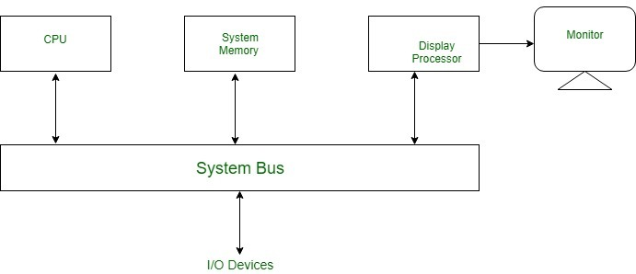
ADVANTAGES:
- Higher resolution as compared to raster scan display.
- Produces smooth line drawing.
- Less Memory required.
DISADVANTAGES:
- Realistic images with different shades cannot be drawn.
- Colour limitations.

Raster scan display
Raster Scan Displays are most common type of graphics monitor which employs CRT. It is based on television technology. In raster scan system electron beam sweeps across the screen, from top to bottom covering one row at a time.A illuminated pattern of spots is created by turning beam intensity on and off as it moves across each row. A memory area called refresh buffer or frame buffer stores picture definition. This memory area holds intensity values for all screen points. Stored intensity values are restored from frame buffer and painted on screen taking one row at a time.Each screen point is referred to as pixels.
In raster scan systems refreshing is done at a rate of 60-80 frames per second. Refresh rates are also sometimes described in units of cycles per second / Hertz (Hz). At the end of each scan line, electron beam begins to display next scan line after returning to left side of screen. The return to the left of screen after refresh of each scan line is known as horizontal retrace of electron beam. At the end of each frame electron beam returns to top left corner and begins the next frame.
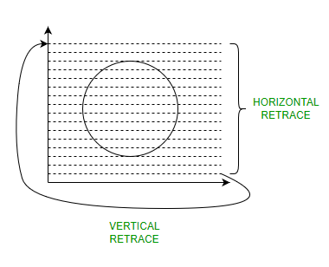
Raster-Scan Display Processor:
An important function of display process is to digitize a picture definition given in an application program into a set of pixel-intensity values for storage in refresh buffer. This process is referred to as scan conversion. The purpose of display processors is to relieve the CPU from graphics jobs.
Display processors can perform various other tasks like: creating different line styles, displaying color areas, etc. Typically display processors are utilized to interface input devices, such as mouse, joysticks.
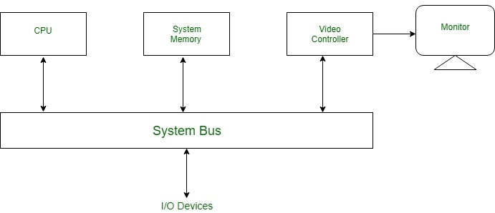
ADVANTAGES:
- Real life images with different shades can be displayed.
- Color range available is bigger than random scan display.
DISADVANTAGES:
- Resolution is lower than random scan display.
- More memory is required.
- Data about the intensities of all pixel has to be stored.

Flat panel display

Flat-Panel Devices are the devices that have less volume, weight, and power consumption compared to Cathode Ray Tube (CRT). Due to the advantages of the Flat-Panel Display, use of CRT decreased. As Flat Panel Devices are light in weights that’s why they can be hang on walls and wear them on our wrist as a watch. Flat Panel Display (FPD) allow users to view data, graphics, text and images.
Types of Flat Panel Display:
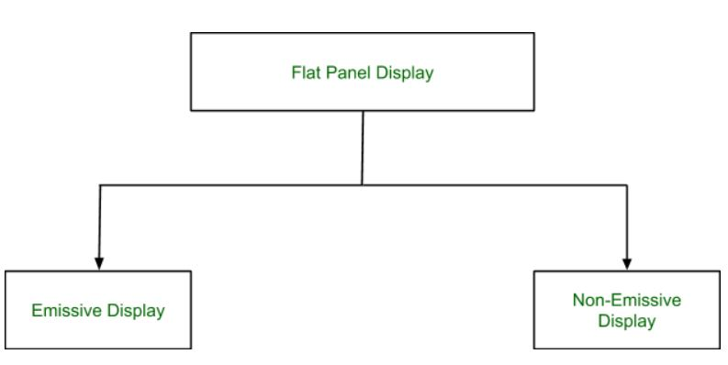
1. Emissive Display:
The Emissive Display or Emitters are the devices that convert electrical energy into light energy.
Examples: Plasma Panel, LED (Light Emitting Diode), Flat CRT.

2. Non-Emissive Display:
Non-Emissive Display or Non-Emitters are the devices that use optical effects to convert sunlight or some other source into graphic patterns.
Examples: LCD (Liquid Crystal Display)

Advantages of Flat Panel Devices:
- Flat Panel Devices like LCD produces high quality digital images.
- Flat Panel monitor are stylish and have very space saving design.
- Flat Panel Devices consumes less power and give maximum image size in minimum space.
- Flat Panel Devices use its full color display capability.
- Full motion video can be viewed on Flat Panel Devices without artifacts or contrast loss.
Disadvantages of Flat Panel Devices:
- They are very expensive compared to CRTs.
- They have very high refresh rates.
- Slow response times.
- They may be heavier and bulkier than other display types.

LED display
A LED display utilizes LED (Light-Emitting Diode) technology. LED stands for Light Emitting Diode. These diodes are tiny little bulbs that you might have seen on electronic devices.
Large LED displays use a large number of these diodes to light up the screen. These diodes are low power consumption devices that provide high brightness. As a result, an LED screen has several benefits over other display alternatives.
The fluorescent bulbs used earlier could only give black and white tones. However, an LED screen can display the entire colour spectrum by combining red, blue, and green colours (RGB).
The advantages of an LED screen are so many that you can find LED screens everywhere. From TVs to computer monitors to high-resolution billboards in shopping centres and LED video wall applications.
Short History of The Evolution of LED Displays
Even though LED display technology has become popular in the last 5-6 years, the evolution of the LED screen has taken over half a century. Here are some keystone events in this evolution:
- Nick Holonyak, an employee of General Electric, invented the first LED in 1962. It was a red LED and only red LEDs were available for the next 10 years.
- In 1969, Hewlett Packard made the first LED display- the HP Model 5082-7000 Numeric Indicator.
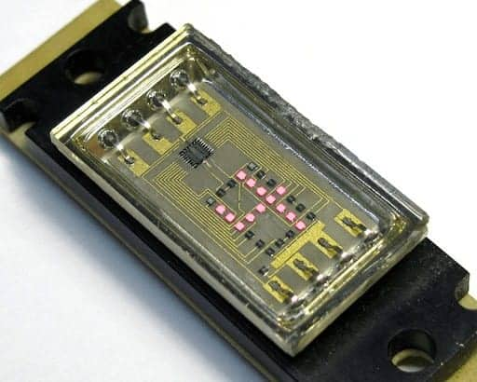
Image: HP Model 5082-7000 Numeric Indicator
- The first real application of an LED display takes place in U2’s Popmart tour of 1997. The display was 52m wide, 17m high, and used 150,000 light-emitting diodes. It was made on a mesh that could be rolled up for transport.
- In 2008, Sony created the world’s first OLED television, which was also the world’s thinnest TV at the time at a thickness of just 3 mm. This OLED television brought the benefits of LED screens to the limelight.
- By 2014, the manufacturing of plasma TVs was stopped in the US and replaced by LCD and LED televisions.
How Do LED Displays Work?
LED displays make use of a huge collection of light-emitting diodes on a flat panel. These diodes are either red, blue, or green. Each of these diodes is capable of emitting light of different brightness.
Just like you learned in art class, two or more colours can combine to create new colours. Similarly, red, blue, and green light from these diodes combined in varying ratios create every colour on the spectrum.
If you get close enough to an LED display, you can notice the individual diodes on the television panel.
Important Technical Terms to Know
While we are talking about LED technology, here are some LED display parameters that you should be familiar with:
- Pixel Pitch – Pixel pitch is the distance between the centres of two adjacent individual pixels on the LED panel. A short pitch results in high resolution and better picture quality. The minimum viewing distance from the LED display is also determined by the pixel pitch. If you view the LED display from a closer distance, you can spot the individual LEDs.
- Pixel Density – Pixel density is the number of pixels present on a given area of the screen. Generally, it is measured in pixels per inch (ppi). The quality of an image displayed on a screen improves significantly as the pixel density increases. Note that pixel density in smaller devices like the screen on your smartphones is considerably higher than large devices like a television or LED video wall. For instance, an iPhone may have a pixel density of over 458 ppi, while a 50-inch 4K TV might have only 80 ppi.
- LED Viewing Angle – The angle from the centre of the LED display at which picture brightness becomes less than 50% of the nominal. In simple terms, this angle tells us the maximum position at which the viewer can still clearly see the display image. For instance, if the angle is 40 degrees, the viewer can still see the image correctly 20 degrees left and 20 degrees right of the screen.
- LED Scan Rate – LED scan rate is a ratio that represents how much of the LED array lights up at a given point. For instance, a scan rate of 1:16 means 1/16th of the LEDs is lit at any given instant. After, the display moves to the next 1/16th. Not all the LEDs are activated. Doing so would result in high power consumption and require more processing power. Instead, a fraction of the LED array is lit at a given instant. Then the principle of Persistence of Vision is used, which means the image our eyes see lasts for a fraction of time.
What are the Different Types of LED Displays?
Based on their construction, LED screens can be categorized into various types. Each of these types has its purpose. Here are a few of the common categories:
Dot-Matrix LED Display
Dot-matrix LED displays are used to show numbers, alphabets, characters, and simple graphics. These displays consist of a rectangular array of LEDs followed by a space. They can be mounted serially to create a dot-matrix display.
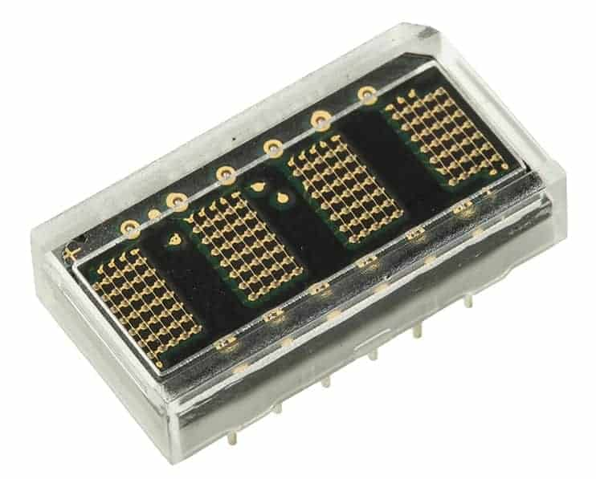
These diodes are programmed to light up according to the number or character that is to be displayed. Each character requires about 5×8 pixels (or LEDs).
Because there is individual control over each LED, a dot matrix display provides more details and intricate graphics than a segmented display.
These displays can be used in meters, industrial controls, medical equipment, billboards, hoardings, and other uses.
7-Segment Display
7-segment displays are used to present numbers by splitting the display into 7 light segments.
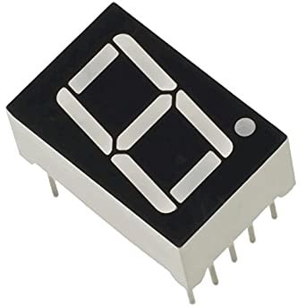
These segments are arranged in a formation that looks like the number ‘8’. In this formation, every number from 0-9 can be presented by lighting the appropriate segment of the display.
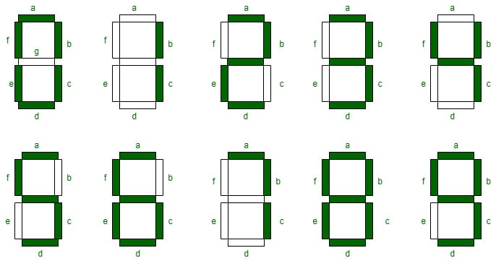
These displays are one of the most common and simple and you will find them anywhere numbers are to be presented. A common example of this is digital clocks, digital thermometers, calculators, and other digital communications devices.
It is important to note that while 7-segment displays can recreate all the numbers, they cannot be used for lettering.
14-Segment LED Display
14-segment displays retain the basic 7-segment shape, plus additional LED segments placed in the diagonals and centre of the 8 shape.
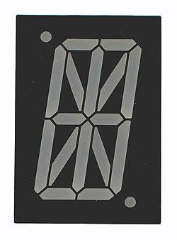
These added sections make it possible to display letters along with numbers. This configuration is also known as the Starburst LED display.
These displays were popularized by arcade games in the ’80s. Even today, they are used in a wide range of applications that require specific requirements, such as a retro look or a simple alphanumeric display.
16-Segment LED Display
16-segment LED display improves upon the 14-segment design by further splitting the top and bottom horizontal segments of the 8-figure. The addition of these segments adds some clarity when displaying alphabets.
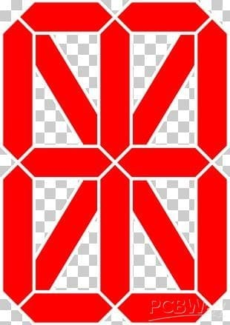
Complex LED Displays
Segmented and dot-matrix designs are sufficient for basic graphics and alphanumeric characters. But they are unsuitable for purposes such as TV, computer monitors, or other displays that require recreation of a complete spectrum of colours and complex graphics.

For this purpose, the LED screens are large-scale in nature, employing millions of LEDs. Unlike the segmented displays, the complex large-scale arrangements do not have segments or gaps between the LEDs.
Benefits of LED Displays
One important question to ask at this point is ‘why are LED displays so popular?’. If you remember the LED technology that we mentioned earlier, you might have guessed the benefits it can provide.
Even so, the advantages of LED displays are far more than what meets the eye at first glance. Some of them are:
- Size: Light-emitting diodes are tiny. For this reason, LED displays are smaller than any other alternative display technology that you can think of. They can be one-third the thickness of an LCD of the same screen size.
- Power Consumption: LEDs consume a minimal amount of electricity. Therefore, even a large LED display consumes a fraction of the electricity consumed by similar-sized LCD screens.
- Image Quality: LED screens have an RGB contrast, which means they can recreate true blacks and true whites. This creates a better image quality than other displays.
- Lifespan: Due to no moving parts and a simple design, LED displays tend to last longer than LCD screens or other displays.
- Viewing Angle: LED displays are evenly lit. Therefore, they provide a wider viewing angle.
- Eye Strain: LED displays offer greater control over high brightness and other features that can help reduce eye strain.

LCD display
What is LCD?

LCD is a flat display technology, stands for "Liquid Crystal Display," which is generally used in computer monitors, instrument panels, cell phones, digital cameras, TVs, laptops, tablets, and calculators. It is a thin display device that offers support for large resolutions and better picture quality. The older CRT display technology has replaced by LCDs, and new display technologies like OLEDs have started to replace LCDs. An LCD display is most commonly found with Dell laptop computers and is available as an active-matrix, passive-matrix, or dual-scan display. The picture is an example of an LCD computer monitor.
The LCD displays are not only different in terms of heavy than CRT monitors; even the process of working of them is also different. An LCD contains a backlight rather than the firing electrons at a glass screen, which offers light to individual pixels arranged in a rectangular grid. All pixels have a sub-pixel, red, green, and blue, which can be turned on or off. The display appears black if all of a pixel's sub-pixels are turned off and appears white if all the sub-pixels are turned on 100%. The millions of color combinations can be possible with the help of adjusting the individual levels of red, green, and blue light.
As compared to CRT technology, LCD consumed much less power and allowed displays to be much thinner that also made them very less heavy. Instead of emitting light, LCDs work on the principle of blocking light. In an LCD, where an LED ejects light, the liquid crystals produce a picture with the help of using a backlight. Also, while comparing with gas-display and LED displays, LCDs consume less energy.
The CRT monitors and TVs have a refresh rate, but LCD screens do not have a refresh rate. If you feel a problem with eye strain with the CRT monitor, you might need to change the monitor's refresh rate setting on your CRT screen. But with the new LCD screen, you do not need to adjust the refresh rate setting. Some LCD computer monitors provide support for VGA cables, and most have a connection for HDMI and DVI cables. But offering support for VGA cables is much less common.
Different Types of LCD
There are various kinds of LCD, which are discussed below:
- Twisted Nematic (TN): The TN LCDs are very common that are used in several types of displays over the industries, which led to its production much frequently. As compared to other displays, these displays are inexpensive and have high response times; therefore, these are most commonly used by gamers. These displays are more appropriate for daily operations, but they have low contrast ratios, viewing angles, and reproduction of color. These displays are available with 240 hertz (Hz) as these are the only gaming displays.
- In-Plane Switching (IPS): In Panel Switching displays give better picture quality, vibrant color precision & difference while comparing with TN LCDs. Graphic designer and some other applications commonly use these displays; hence, these are considered to be the best LCD.
- Vertical Alignment Panel (VA Panels): The vertical alignment panels are considered to deliver the medium quality between in-plane switching panel and Twisted Nematic technology. As compared to TN-type displays, this kind of panel has color reproduction with higher quality as well as best viewing angles features. Also, these panels are much sufficient for daily use and more reasonable, but these contain a low response time. As compared to the Twisted Nematic display, these panels generate deeper blacks with better colors. While comparing with TN kind displays, numerous crystal alignments can permit better viewing angle. Additionally, these displays are costly comparing to other displays. Hence these come with a tradeoff.
- Advanced Fringe Field Switching (AFFS): AFFS LCD is a top performer and offers an extensive choice of color reproduction. These displays provide good image quality. Generally, these displays are most commonly used in highly advanced applications such as viable airplane cockpits.
How LCDs Work?
The principle behind the LCDs is that for switching pixels on and off to reveal a specific color, LCD screens use liquid crystals. And, the molecule tends to untwist at the time of electrical current is applied to the liquid crystal molecule. This becomes the reason for a change in the angle of the top polarizing filter as well causes the angle of light, a light that is passing through the molecule of the polarized glass. Consequently, with the help of an individual area of the LCD, a small light is allowed to permit the polarized glass.
Thus, as compared to other areas, this particular area will become dark. Instead of emitting light, LCDs work on the principle of blocking light. A reflected mirror is arranged at the backside at the time of constructing the LCDs. An indium-tin-oxide is used to make the electrode plane, which is kept on top of the device. Also, on the bottom of the device, a polarized glass with a polarizing film is added. With the help of a common electrode, the LCD's complete area has to be enclosed, and the liquid crystal matter should be above it.
Then comes another polarizing film on top, and on the bottom, in the form of rectangle, the second piece of glass comes with an electrode. But make sure that both pieces are located on the right angles. The light passes through the front of the LCD when there is no current, reflecting with the help of a mirror and bounced back. A screen is in front of the light that is made up of pixels colored red, green, and blue. In order to reveal a certain color or keep that pixel black, the liquid crystals work for turning a filter on or off. This is the reason; the LCD monitors and TVs consume much less power as compared to CRT monitors or televisions.

Plasma display
The first plasma displays that were available were technically televisions because they did not have TV tuners. The television tuner is the device that converts a television signal from a cable wire or any other means into a video image. Since the plasma displays lacked tuners, they were used as simple monitors that display a standard video signal. Recent developments have made inbuilt digital television tuners. Plasma Display Panel is an emissive display which means that the panel itself is the light source. In comparison to a transmissive display, where the light source is separate and light is passed through the panel to create an image, PDPs are extremely bright and light-tolerant flat panel display technology that utilizes a gas discharge principle thus also known as gas discharge display.
The working of the Plasma Display Panel is as follows:
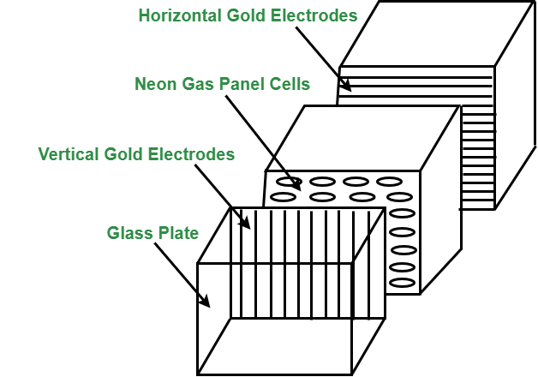
Plasma Panel Display
- Plasma Display Panel is composed of two parallel sheets of glass that enclose a mixture of discharge gases composed of helium, neon, and xenon.
- On the inner side of the glass, plates are Ribs, which help keep the glass plates parallel.
- Groups of electrodes sit at right angles between the panes forming rectangular compartments, or cells, between the glass sheets.
- Phosphorus is embedded within each cell that individually emits red, green, or blue light and collectively creates a single color pixel.
- Selectively applying voltages to the electrodes causes them to generate a discharge in the panel’s dielectric layer and on its protective surface. This generates ultraviolet light that excites the phosphors, stimulating them to emit light.
- The picture definition is stored in a Refresh Buffer, voltage is applied to refresh the pixel positions 60 times per second.
Advantages of Plasma Display Panel :
- Plasma Display Panel are thin lightweight and take up less space than other displays which makes them easy to install anywhere.
- Plasma Display Panel offers uniform brightness.
- They show images without distortion and avoid problems such as misregistered colors and lack of focus.
- They also resist interference from magnetic fields, are free from distortion and are viewable from a wide angle.
- Plasma Display Panel capable of producing deeper blacks allowing superior contrast ratio.
- It provides a wider viewing angle than those of LCD due to which images do not suffer from degradation at high angles.
- Plasma Display Panel are suitable for multimedia usage because they can display computer images as well as full-color, full-motion pictures.
Disadvantages of Plasma Display Panel :
- Plasma Display Panel uses more electricity, as an overlay than an LCD TV.
- Earlier generation Plasma Display Panel were more susceptible to screen burn-in and image retention, recent models have a pixel orbiter that moves the entire picture faster than is noticeable to the human eye, which reduces the effect of burn-in but does not prevent it.
- Earlier generation displays had phosphors that lost luminosity over time, resulting in the gradual decline of absolute.
- Due to the strong infrared emissions inherent in the technology standard Infrared repeater systems cannot be used in the viewing room. A more expensive “plasma compatible” sensor needs are used.

Touch screen
A touch screen is both an electronic display screen and an input device. A user uses hand motions and fingertip movements to tap photos, control items, or input words on a computer, tablet, smartphone, or touch-controlled appliance screen. The screens are pressure-sensitive and can be operated or handled with fingers or a pen.
A touch screen is both an electronic display screen and an input device. A user uses hand motions and fingertip movements to tap photos, control items, or input words on a computer, tablet, smartphone, or touch-controlled appliance screen. The screens are pressure-sensitive and can be operated or handled with fingers or a pen.

Components of Touch Screen
- Touch sensor – The structure of touch sensors depend on the type of touch screen we’re using. Its work is to sense any valid touch, valid touch meaning by a finger or hand.
- Controller – Controller is a small pc card. It gives the location of the touch to the software of the device.
- Software drivers – Software drivers allow the software to work in cooperation with the touch screen. These drivers are developed using the C programming language.
Working of Touch Screen Technology
Touch screen technology works on several principles, each is used to detect and respond to touch inputs. Capacitive touchscreens, one of the most common types, works by measuring changes in capacitance when a conductive object, like a finger, touches the screen, disrupting an electrostatic field. Resistive touchscreens work by pressing two flexible layers together, completing a circuit and detecting touch based on changes in electrical current flow. Surface Acoustic Wave (SAW) touchscreens emit ultrasonic waves over the screen’s surface, with touch points identified by disruptions in the wave pattern. Infrared touchscreens use infrared light beams across the screen, with touch points detected by interruptions in the beams. These technologies collectively enable intuitive interaction with electronic devices, revolutionizing user interfaces across a wide range of applications.
Types of Touch Screens
- Resistive Touch Screen: It is the simplest and most commonly used touch screen. Resistive touch screens when pressed hard enough, bend, and resists the touch hence, the name. It consists of two layers that can conduct electricity, the outer layer is resistive and the inner layer is conductive. These two layers are separated by tiny dots called spacers until the screen is touched. An electrical current constantly runs through the two layers, when all of a sudden a finger hits the screen, the two layers get pressed together and the electrical current changes. The device’s software feels a change in this particular spot and does its work means that it fulfills the function that corresponds to that place. Some pros of this type are that it is reliable and durable. There are some cons of this type that is it’s pretty hard to read the screen due to their multiple layers, the more light falls on the display the harder it is to read, also can’t zoom in to see more clearly because they can handle only one touch at a time.
- Capacitive Touch Screen: These touch screens are made of indium tin oxide or copper, both of them keep electrical charges in very thin wires. The capacitive screen changes the electric current when it comes into contact with anything that holds a charge that means even our skin. There are two types of capacitive screens :
  - Projective: Uses a tight grid of special sensor chips.
  - Surface: uses small sensors in the corner as well as a paper-thin film evenly distributed over the screen.
As soon as a finger comes in contact with the screen, it transfers a small amount of electrical charge back to the finger. As a result, there forms a complete circuit which leads to a voltage drop in a particular place. The software analyses the location of the voltage drop and follows the command accordingly.
- Infrared: Their display shines infrared light in the form of web or grids in front of the screen. As soon as someone touches the screen, a couple of infrared rays gets interrupted and gives a reaction. By analyzing the location of the interruption, a microchip will do the job accordingly.
- Surface Acoustic Wave Technology: Their technology uses sound to detect any touch. The screen creates ultrasonic sound waves at its edges, and they get reflected back and forth all over the screen. These ultrasonic sounds are too high pitched to be heard by the human ear. As soon as someone touches the screen, not only the sound waves get disturbed but the finger also absorbs some wave’s energy. This is how the microchip controller understands where the screen is hit.
Advantages of Touch Screen
- Reduces error while accessing something.
- Provides easy and fast access to any file.
- Reduces the need of extra input devices like keyboard, mouse, etc. hence saves energy.
- Provides good security.
Disadvantages of Touch Screen
- They are not suitable to store very large amount of data.
- Installing a large no. of touch screen devices can be pretty expensive hence not cost effective.

Graphics Functions and Standards
Graphics functions are used to create and manipulate images, shapes, and visual elements in computer programming. These functions can be categorized into:
- Basic Drawing Functions:
  - Line Drawing – line(x1, y1, x2, y2)
  - Circle Drawing – circle(x, y, radius)
  - Rectangle Drawing – rectangle(x1, y1, x2, y2)
  - Polygon Drawing – polygon(points_list)
- Color and Fill Functions:
  - Setting Colors – setColor(color)
  - Filling Shapes – fillPolygon(points, color)
- Transformations:
  - Scaling – Resize the object.
  - Translation – Move the object.
  - Rotation – Rotate the object.
- Text Functions:
  - drawText(x, y, "Hello") – Displays text at a given position.

Graphics File Formats
Different image file formats store graphics data in different ways, each with its own advantages and disadvantages.

1) Raster (Bitmap) Image Formats
Raster images are made up of pixels and are resolution-dependent.
- JPEG (Joint Photographic Experts Group)
  - Advantages: High compression, widely supported.
  - Disadvantages: Lossy compression, reduces quality.
- PNG (Portable Network Graphics)
  - Advantages: Lossless compression, supports transparency.
  - Disadvantages: Larger file size than JPEG.
- GIF (Graphics Interchange Format)
  - Advantages: Supports animation, transparency.
  - Disadvantages: Limited to 256 colors.
- BMP (Bitmap Image File)
  - Advantages: High quality, no compression.
  - Disadvantages: Very large file size.

2) Vector Image Formats
Vector graphics use mathematical equations to define shapes and are resolution-independent.
- SVG (Scalable Vector Graphics)
  - Advantages: Scalable without quality loss, small file size.
  - Disadvantages: Not suitable for complex images like photographs.
- EPS (Encapsulated PostScript)
  - Advantages: High quality for printing, supports transparency.
  - Disadvantages: Not widely supported in web browsers.
- PDF (Portable Document Format)
  - Advantages: Preserves vector and raster graphics, widely used for documents.
  - Disadvantages: Complex for editing.

Comparison: Raster vs Vector Graphics
Feature | Raster (JPEG, PNG) | Vector (SVG, EPS)
Resolution | Fixed (pixel-based) | Scalable (mathematical)
File Size | Larger (high detail) | Smaller (simple graphics)
Best For | Photos, textures | Logos, diagrams, icons
Editability | Limited (pixel data) | Easily editable

